TODAY’S TAKEAWAYS
GRAMMAR | VOCABULARY | PRONUNCIATION
 | - hard to beat

ORDINAL NUMBERS – 1st TO 100th
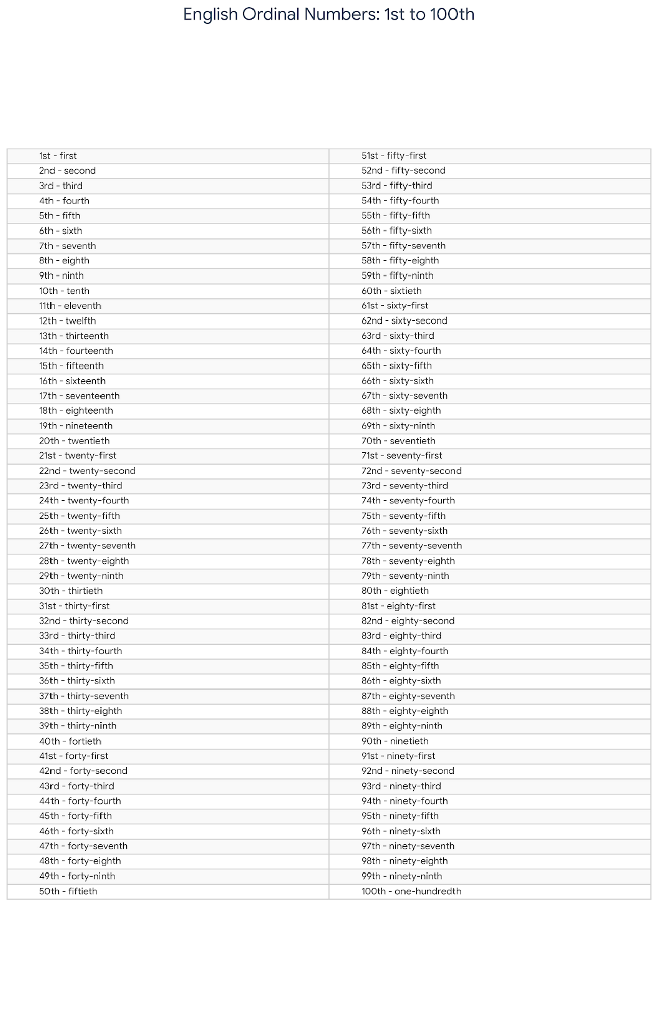

Usage Examples
Ordinal numbers are used to indicate the position or order of something in a sequence.
- Dates: Ordinal numbers are essential for dates.
  - “My birthday is on October 12th.”
  - “The meeting is scheduled for the 1st of May.”
- Sequences and Rank: Used to describe finishing positions or order.
  - “She finished in second place in the marathon.”
  - “This is the third time I've called you today.”
- Floors of a Building:
  - “Our apartment is on the 15th floor.”
  - “Take the elevator to the fourth floor.”
- Centuries:
  - “We are currently living in the 21st century.”
Important Rules and Exceptions
When forming and using ordinal numbers, keep these specific points in mind:
- The "11, 12, 13" Exception: While most numbers ending in 1, 2, or 3 use the suffixes -st, -nd, and -rd, the numbers 11, 12, and 13 are exceptions. They use the suffix -th (11th, 12th, 13th). Once you reach 21, the rule returns to 21st, 22nd, 23rd.
- Spelling Changes: Several numbers undergo spelling changes when becoming ordinals:
  - Five → Fifth (not fiveth)
  - Eight → Eighth (only one 't')
  - Nine → Ninth (the 'e' is dropped)
  - Twelve → Twelfth (the 've' changes to 'f')
- The "-y" to "-ieth" Rule: For tens (20, 30, 40, etc.), the final -y changes to -ie before adding -th.
  - Twenty → Twentieth
  - Forty → Fortieth
  - Ninety → Ninetieth
- Hyphenation: When writing compound ordinal numbers (like 21st, 44th, 99th), always use a hyphen between the tens and the units: twenty-first, forty-fourth, ninety-ninth.

Review of useful sentences about deadlines.
Change the sentences from Portuguese into English:
1 - O prazo é 14 de abril.
The deadline is April 14th.
2 - Vamos adiar até 23 de maio.
Let’s postpone until May 23rd.
3 - Nós combinamos a data de entrega do projeto para 4 de agosto.
We agreed on a project delivery date of August 4th.
4 - Estabeleceu-se um prazo de 75 dias para executar o projeto do começo ao fim.
A deadline/term of 75 days was established/set to execute / for the execution of the project from beginning/start to end.
5 - O prazo expira em 5 de dezembro.
The deadline expires on December 5th (fifth)
6 - O prazo foi extendido até 16 de dezembro.
The deadline was extended to December 16th.
7 - O prazo foi extendido em 15 dias.
The deadline was extended in/to/by 15 days.
8 - Nós vamos começar a desenhar o projeto na próxima segunda, às 10h00.
We are going to start designing the project next Monday, at 10.00 am.
9 - Vamos acelerar a entrega de tarefas para terminar tudo até 23 de outubro.
Let’s speed up the delivery of tasks to finish everything/it all by October 23rd.

PAST SIMPLE & PAST CONTINUOUS

